CFD Packed Column Models for Points Source Carbon Capture
Yucheng Fu¹, Rajesh Kumar Singh¹, Chao Zeng¹, Jie Bao¹, Zhijie Xu¹
¹Pacific Northwest National Laboratory, Richland, WA 99352, USA

This document outlines the CFD models developed to analyze the performance of packed columns in point source carbon capture applications. The models incorporate three distinct packing types: random packing[1–4], structure packing[5–8] and triply periodic minimal surface (TPMS) packing [9]. These CFD models are available in both Stereolithography (.stl) and Nastran (.nas) file formats.

Random Packing

Raschig ring representative column
Packing Element: Raschig ring
Column size: H = 6 cm, ID = 7.62 cm
Model description: random packed column filled Raschig ring elements. The specific area of the column is a_{p} = 857.5 m²/m³
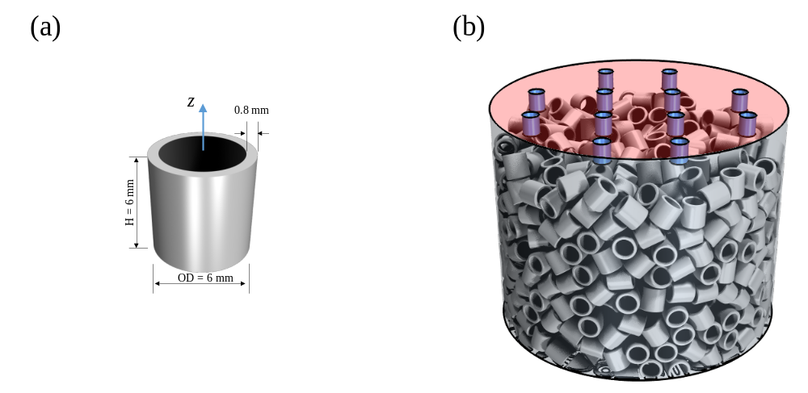
Figure 1 Visualization of (a) single element and, (b) Raschig ring representative column CFD model.

Pro-Pak representative column
Packing element: Pro-Pak
Column size: H = 6 cm, ID = 7.62 cm
Model description: random packed column filled Pro-Pak elements. The specific area of the column is a_{p} = 939.5 m²/m³
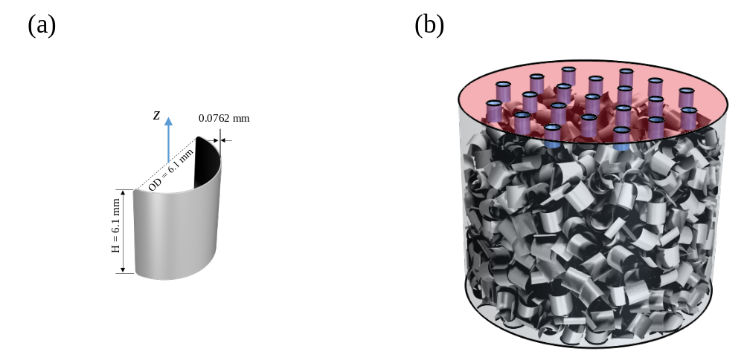
Figure 2 Visualization of (a) single element and (b) Pro-Pak ring representative column CFD model.

Pall ring representative column
Packing element: Pall ring
Column size: H = 6 cm, ID = 10 cm
Model description: random packed column filled Pall ring elements. The specific area of the column is a_{p} = 209.1 m²/m³

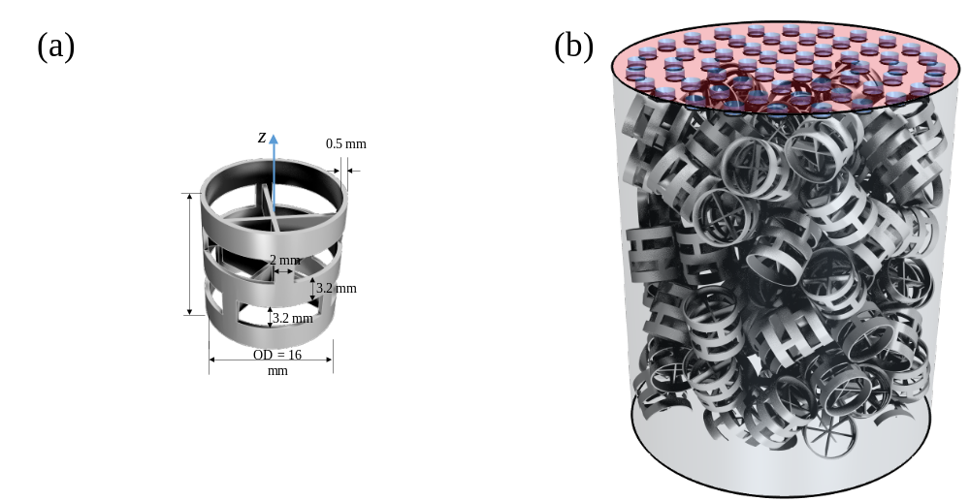
Figure 3 Visualization of (a) single element and (b) Pall ring representative column CFD model.

Raschig ring bench-scale column
Packing element: Raschig ring
Column size: H = 53.3 cm, ID = 7.62 cm
Model description: random packed column filled with over eight thousand Raschig ring elements. The model is a full-size bench-scale column with a packing height over 50 cm. The solvent can be injected using single or multiple inlets setup to investigate the solvent distribution process during the operation.

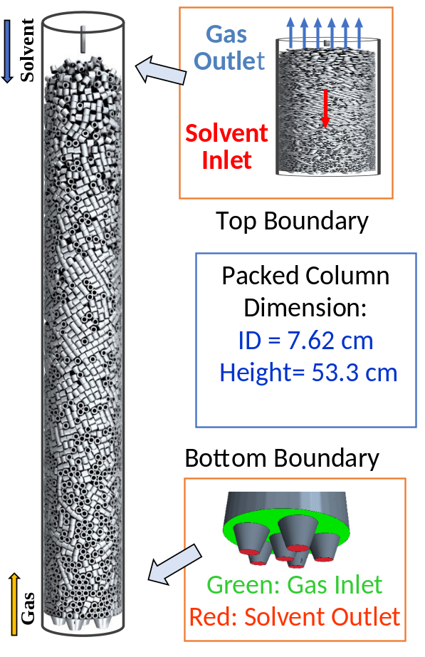
Figure 4 Visualization of Raschig ring bench-scale column CFD model.

Structure Packing

M250Y periodic column
Packing element: Mellapak 250Y
Column size: Height = 10 cm, Width = 9.8 cm, Depth = 8 cm
Model description: Structure packed column filled with Mellapak 250Y sheets. The periodic domain contains 3 x 3 x 3 repeated units of the Mellapak 250Y in the computational domain.
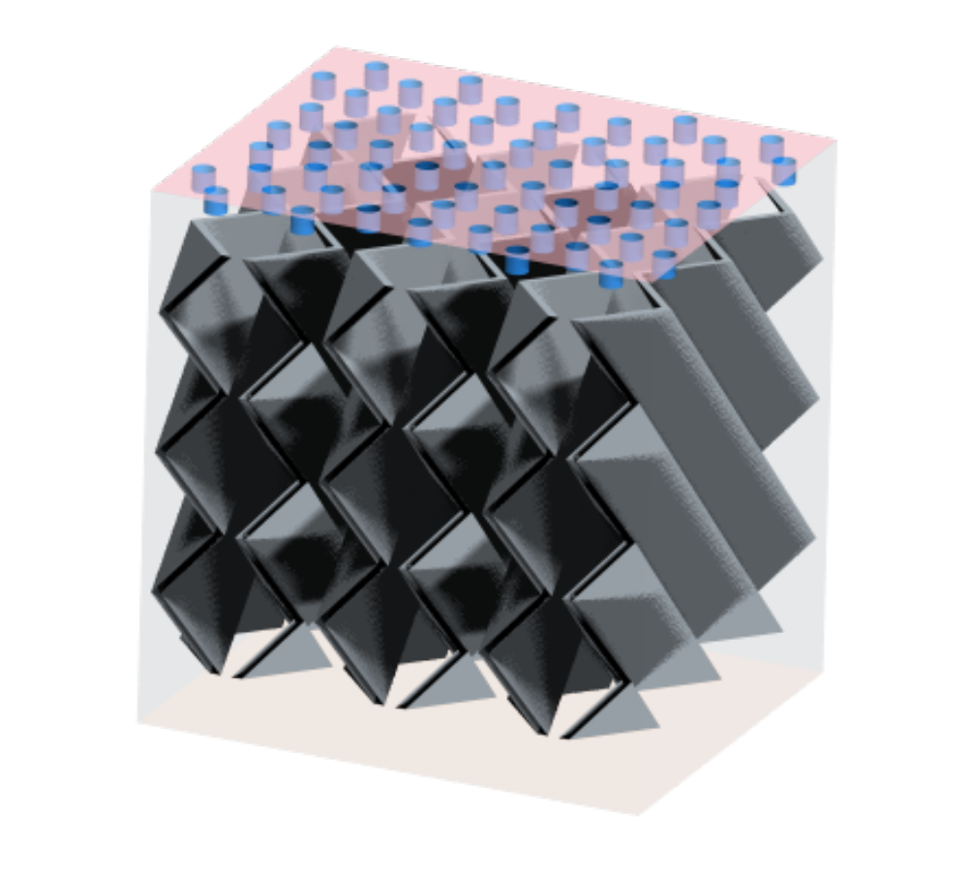
Figure 5 Visualization of Mellapak 250Y periodic column CFD model.

M500Y representative column
Packing element: Mellapak 500Y
Column size: H = 20 cm, ID = 7.62 cm
Model description: Structure packed column filled Mellapak 500Y sheets. Two packing units are stacked in the column with a rotation of 90 degree for the second unit.
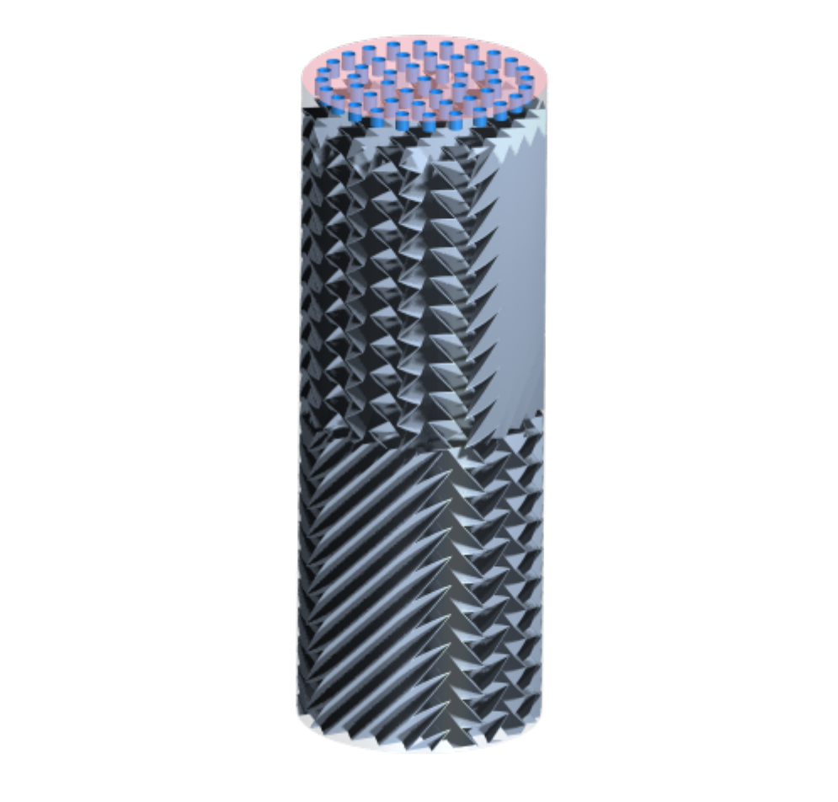
Figure 6 Visualization of Mellapak 500Y representative column CFD model.

TPMS

Schwarz-D representative column
Packing: Schwarz-D surface
Column size: H = 7 cm, ID = 7.62 cm
Model description: packed column filled Schwarz-D TPMS surface with an average packing wall thickness around 0.4 mm. The specific area of the column is a_{p} = 620 m²/m³
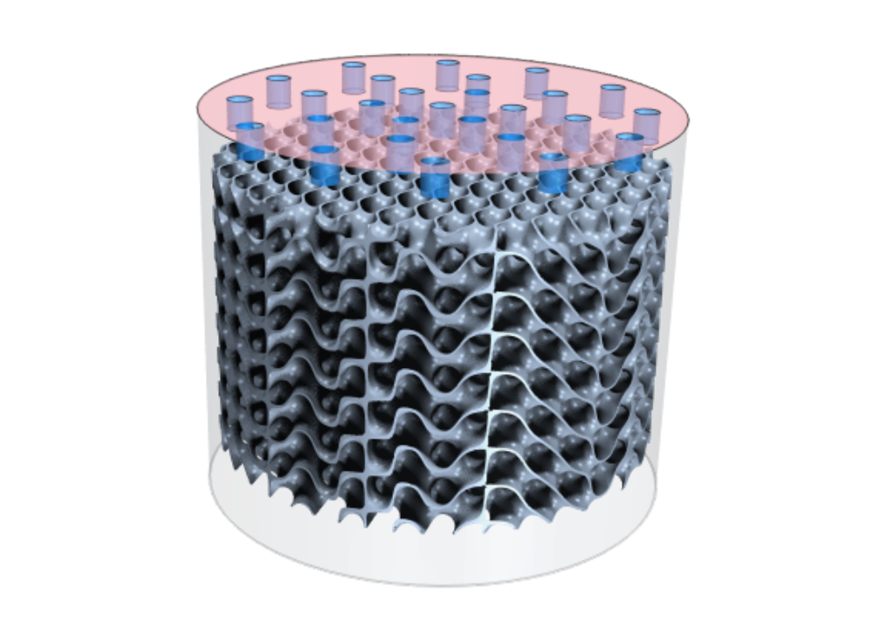
Figure 7 Visualization of Schwarz-D representative column CFD model.

Gyroid representative column
Packing: Gyroid surface
Column size: H = 7 cm, ID = 7.62 cm
Model description: packed column filled Gyroid TPMS surface with an average surface wall thickness around 0.2 mm. The specific area of the column is a_{p} = 607 m²/m³

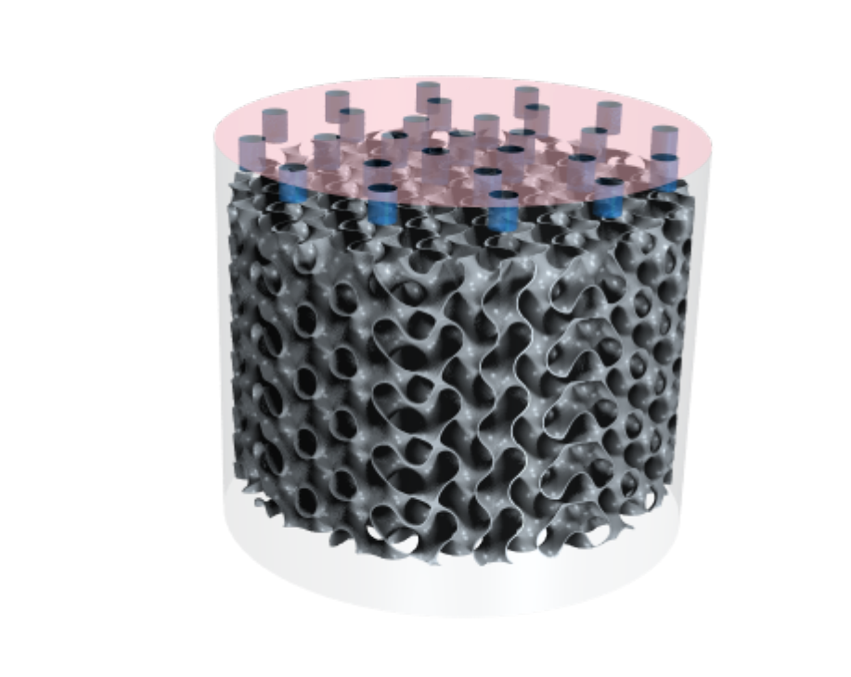
Figure 8 Visualization of Gyroid representative column CFD model.

Reference
[1] Y. Fu, J. Bao, R. Singh, C. Wang, Z. Xu, Investigation of countercurrent flow profile and liquid holdup in random packed column with local CFD data, Chem Eng Sci. 221 (2020). https://doi.org/10.1016/j.ces.2020.115693.
[2] B. Bartoldson, R. Wang, Y. Fu, D. Widemann, S. Nguyen, J. Bao, Z. Xu, B. Ng, Latent Space Simulation for Carbon Capture Design Optimization, ArXiv. (2021).
[3] B. Bartoldson, R. Wang, Y. Fu, D. Widemann, S. Nguyen, J. Bao, Z. Xu, B. Ng, Latent Space Simulation for Carbon Capture Design Optimization, in: Proceedings of the 36th AAAI Conference on Artificial Intelligence, AAAI 2022, 2022.
[4] Y. Fu, J. Bao, R.K. Singh, R.F. Zheng, C.M. Anderson-Cook, K.S. Bhat, Z. Xu, The influence of random packed column parameters on the liquid holdup and interfacial area, AIChE Journal. 68 (2022). https://doi.org/10.1002/aic.17691.
[5] R.K. Singh, J. Bao, C. Wang, Y. Fu, Z. Xu, Hydrodynamics of countercurrent flows in a structured packed column: Effects of initial wetting and dynamic contact angle, Chemical Engineering Journal. 398 (2020). https://doi.org/10.1016/j.cej.2020.125548.
[6] R.K. Singh, J.E. Galvin, X. Sun, Hydrodynamics of the rivulet flow over corrugated sheet used in structured packings, International Journal of Greenhouse Gas Control. 64 (2017) 87–98. https://doi.org/10.1016/j.ijggc.2017.07.005.
[7] R.K. Singh, J.E. Galvin, X. Sun, Multiphase flow studies for microscale hydrodynamics in the structured packed column, Chemical Engineering Journal. 353 (2018) 949–963. https://doi.org/10.1016/j.cej.2018.07.067.
[8] C. Zeng, Y. Fu, R. Singh, J. Bao, Z. Xu, Differentiation of static and dynamic interfacial area in the structured packed column, Chem Eng Sci. 260 (2022). https://doi.org/10.1016/j.ces.2022.117877.
[9] R.K. Singh, Y. Fu, C. Zeng, D.T. Nguyen, P. Roy, J. Bao, Z. Xu, G. Panagakos, Hydrodynamics of countercurrent flow in an additive-manufactured column with triply periodic minimal surfaces for carbon dioxide capture, Chemical Engineering Journal. 450 (2022) 138124. https://doi.org/10.1016/j.cej.2022.138124.

